School District of Baraboo



Academic and Career Planning

&

Education for Employment Plan

Approved by the Board of Education:

8/27/18

8/28/17

|  |
| --- |
|  |
|  |
| Non-Discrimination Notice  The School District of Baraboo does not discriminate on the basis of sex, race, national origin, ancestry, creed, pregnancy, religion, marital or parental status, sexual orientation, gender identity, gender expression, or physical, mental, emotional, or learning disability or handicap in its education programs (including career or technical educational programs) or activities. The School District of Baraboo will not tolerate harassment based on sex.  No student or employee of the School District of Baraboo shall be denied fair and equal treatment under the law and the District is required by Title IX not to discriminate in such a manner.  Any employee or student who feels that he/she has been treated in a discriminatory way or denied rights under the law should contact an administrator: School District of Baraboo, 423 Linn Street, Baraboo, WI 53913 or phone (608) 355-3950.  Questions regarding Title IX may be referred to the School District of Baraboo’s Title IX Coordinator:  School District of Baraboo Director of Student Services  423 Linn Street  Baraboo, WI 53913  Phone: (608) 355-3950, x1530  Email: [SEPSDIR@barabooschools.net](mailto:SEPSDIR@barabooschools.net)  Questions regarding Title IX may also be referred to the Office of Civil Rights:  Chicago Office for Civil Rights  U.S. Department of Education  Citigroup Center  500 W. Madison Street, Suite 1475  Chicago, IL 60661  Phone: (312) 730-1560; FAX: (312) 730-1576; TDD: (877) 521-2172  Email: OCR.Chicago@ed.gov |

District Mission

The School District of Baraboo’s mission is to strive for excellence to ensure that every learner is successful in an evolving world. The Thunderbirds are committed to four district strategic directions to guarantee continuous improvement:

* Personalized Learning
* Community Partnerships
* Maximizing the Potential of Learners and Educators
* Modernized Community Campus

We are extremely proud to offer an inclusive school community, rich in offerings, and dedicated to providing a continuum of opportunities to all of our students. Our district is notable for our investment in teacher quality, development of employability skills through business-education partnerships, capacity to deliver personalized instruction through a robust technology infrastructure, and planning for future growth.

Chapter PI-26

All districts in the state of Wisconsin are required to have in place an Education for Employment (E4E) program. The purpose of this program is to prepare elementary and secondary pupils for employment, to promote cooperation between business and industry and public schools, and to establish a role for public schools in the economic development of Wisconsin. The purpose of Education for Employment programs is to do all of the following:

1. Prepare elementary and secondary pupils for future employment.
2. Ensure technological literacy.
3. Promote lifelong learning and good citizenship.
4. Promote cooperation among business, industry, labor, postsecondary school, and public schools.
5. Establish a role for public schools in the economic development of Wisconsin.

As part of this E4E process, Chapter PI-26 also requires every school district to provide Academic and Career Planning (ACP) services to pupils enrolled in grades 6 to 12 in the school district beginning in the 2017-18 school year. Academic and Career Planning is a student-driven, adult-supported process in which students create and cultivate their own unique and information-based visions for postsecondary success, obtained through self-exploration, career exploration, and the development of career management and planning skills.

Education for Employment services provide information and opportunities that will lead to:

1. Career awareness in elementary school
2. Career awareness in middle and high school
3. Career planning and preparation in high school that includes:
   1. Career research,
   2. School supervised work-based learning experiences,
   3. Career decision making,
   4. Application of academic skills, technologies, economics,
   5. Personal financial literacy,
   6. Career and Technical Education (CTE) opportunities,
   7. Labor market information, and
   8. Employability skills.

To read PI-26 in its entirety, please visit <https://docs.legis.wisconsin.gov/code/register/1996/483b/insert/pi26.pdf>

District and Community Demographics

The School District of Baraboo is located about forty miles northwest of Madison, Wisconsin and is comprised of five elementary buildings, one middle school, and one high school. Additionally, our Baraboo Early Learning Cooperative (BELC) serves 4K students and their families in community-based sites. Our total student population for the 2017-2018 school year was approximately 3,000 students. The District also employs approximately 245 certified teachers. A breakdown of the 2017-2018 student population is below:

2017-2018 Total Student Enrollment = 2,995

* Percentage of students identified as English Language Learners: 2.2%
* Percentage of students identified as economically disadvantaged: 39.4%
* Percent of students receiving special education services: 13%

Race and Ethnic Data:

|  |  |  |  |  |  |  |  |
| --- | --- | --- | --- | --- | --- | --- | --- |
|  | American Indian | Asian | Black | Hispanic | Native Hawaiian or Pacific Islander | White | Two or More Races |
| Percentage of Students | 3.2% | 1.2% | 1.3% | 8.8% | 0.1% | 81.4% | 4% |

|  |
| --- |
| Labor Market Statistics  Baraboo is located in Sauk County and is among the most scenic areas in the state. The population for Sauk County is estimated at 63,949 as of July 1, 2016. This represents a growth rate of 3.2% since the 2010 Census. Sauk County’s annual average wage was $34,565 in 2014, representing 79 percent of the statewide average of $43,856. Ninety percent of Sauk County residents are high school graduates, while 22.2% hold a bachelor’s degree or higher.  According to the US Department of Commerce, Sauk County’s Labor Force Participation Rate (LFPR) was 72.1 percent in 2014, more than nine percentage points above the national rate (62.9 percent) and 3.7 points above the state rate (68.5 percent). The three largest labor force sectors in Sauk County in 2014 were Leisure and Hospitality; Trade, Transportation and Utilities; and Manufacturing, with all of them accounting for roughly 60 percent of total employment and 50 percent of total payroll.  The South Central Workforce Development Area (WDA), which includes Sauk County, predicts jobs in the area will increase 11 percent between 2012 and 2022, with an average annual growth of 1.1 percent or 5,066 jobs per year. This ten‐year regional employment is projected to exceed statewide job growth of 7.1 percent. Almost 70 percent of the expected new jobs in the South Central WDA are concentrated in four industries: Education and Health Services; Professional and Business Services; Trade, Transportation and Utilities; and Leisure and Hospitality. The fastest growing sectors are Construction, Professional and Business Services, Educational and Health Services, and Information.  For more information on current labor market statistics, please visit  US Census Data <http://www.census.gov/>  US Labor Statistics <http://www.bls.gov/>  WI Labor Market Information <http://wisconsinjobcenter.org/labormarketinfo/>  County Workforce Profiles <http://worknet.wisconsin.gov/worknet/worknetinfo.aspx?htm=pub_cntyprofiles> |

Education for Employment & the School District of Baraboo Strategic Plan

|  |
| --- |
| In the fall/winter of 2014, a group of school board members, administrators, teachers, support staff, parents, students and community members collaboratively produced our district’s strategic plan through hours of guided consensus building activities. Our Strategic Plan outlines a commitment to continuous improvement in a variety of key areas.  Currently, the four strategic directions for the district are Community Partnerships, Modernized Community Campus, Personalized Learning, and Maximizing Potential of Learners and Educators. Sub-groups of the Strategic Planning Committee continue their work on these four strategic directions by developing yearly goals and reporting to the Baraboo School District Board of Education each quarter. Sub-group goals directly connected to Academic and Career Planning and Education for Employment are outlined below.  **2018-2019 E4E Goals**   * Fully implement a senior exit interview portfolio process with the use of Career Cruising for 2019 graduates * Ensure student (6th-12th) development of Academic and Career Plans * Ensure full-scale implementation of Career Cruising in grades 6-12 * Continue to deepen partnerships with community businesses and local youth-based organizations to enhance educational opportunities for our students   **2017-2018 E4E Goals**   * Onboard and develop deep level of engagement partnerships with five community businesses/service agencies * Deepen partnerships with local youth-based organizations to enhance educational opportunities for students * Research and implement a senior exit interview portfolio process with the use of Career Cruising * Ensure student (6th-12th) development of Academic and Career Plans * Ensure full-scale implementation of Career Cruising in grades 6-12   Education for Employment Activities  **Elementary Activities**  *Baraboo Community Classroom Connection (BCCC):*The School District of Baraboo Strategic Plan includes expanding community partnerships as one of our top priorities. At the elementary level, we are entering our sixth year of the Baraboo Community Classroom Connection project. The BCCC concept matches each elementary classroom with a community business or service provider. We have established approximately 60 partnerships with the BCCC each of the past 6 years.  *Additional Activities: Elementary Career Fair, Counseling Services,* Parent/Teacher Conferences, Advanced Learner Options, Service Learning  **Middle School Activities**  *Career Cruising Course:* Students in 6th grade will use the Career Cruising program to help develop interests, skills and aspirations as they explore various career options. Students will begin to create an Academic Career Plan and develop targeted career, school and life goals.  *Additional Activities:* Academic & Career Planning Portfolio,Counseling Services, Parent/Teacher Conferences, Advanced Learner Options, Project Lead The Way, 4-Year Education Planning  **High School Activities**  Academic & Career Planning, Senior Exit Interview Portfolio, Sophomore Planning Conferences, High School Career Fair, Counseling Services, Parent/Teacher Conferences, Advanced Learner Options, Alternative Diploma/Graduation Programs, Advanced Placement Courses, Youth Apprenticeships, Work-Based Learning, Early College Credit/Start College Now Options, Dual Enrollment, Project Lead The Way, Job Shadowing, College & Work Site Visits, Volunteer Opportunities, Armed Forces Representatives, College Representatives, Industry-Recognized Certification, ACT Preparation.  Academic and Career Planning (ACP)  Beginning in the 2017-18 school year, Education for Employment legislation requires public school districts to provide Academic and Career Planning services to students in grades 6 through 12. It is a District priority to ensure each student has a personalized Academic and Career Plan to prepare them for a post-secondary world. ACP is a student-driven, adult-supported process in which students create and cultivate their own unique and information-based visions for postsecondary success, obtained through self-exploration, career exploration, and the development of career management and planning skills. ACP refers to both a process that helps students engage in academic and career development activities as well as a product that is created and maintained for students’ academic, career, and personal advancement. This awareness and process set the foundation for ongoing exploration of in-demand career pathways and relevant educational opportunities. Through ongoing and collaborative conversations with parents, educators, and community members, students will be empowered to develop an Academic and Career Plan that documents and guides their journey through grades 6 - 12 and beyond.  As illustrated in the table below, there is a difference between a traditional 4-year plan as compared to ACP. ACP is intended to be dynamic and flexible, reflecting students’ coursework, learning, and assessment results; students’ postsecondary plans, aligned with their career, academic, and personal/social goals and financial reality; and students’ records of college and career readiness activities. |

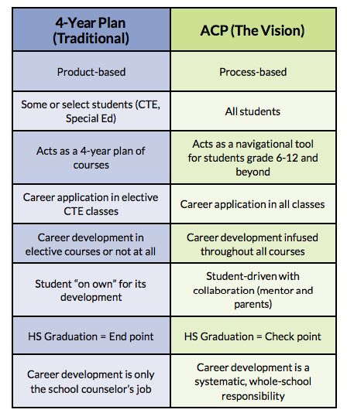

**Why is ACP important?**

1. ACP is based on each STUDENT'S interests, abilities, values, and goals.
2. ACP provides students and parents with the information needed to make INFORMED CHOICES for education, training, and careers while maximizing financial investment.
3. ACP is a CULTURE SHIFT; the purpose of education is not just to get everyone into college; but, rather allow students and their families to choose the best opportunities available to achieve personal education and career goals.
4. ACP HONORS ALL POST-SECONDARY ROUTES to achieve goals, including military, apprenticeship, certification, technical college, and university recognizing that people often move in and out of different routes throughout their lives as needed.
5. Schools Districts are ALREADY DOING SOME OF THE ACTIVITIES RELATED TO ACP such as conferencing, career exploration, career interest inventories, intentional course sequencing, etc. The goal will be to integrate these services into a seamless system of ACP service delivery.
6. ACP requires EVERYONE TO SUPPORT STUDENTS in the process, including academic teachers, administrators, community members and parents.

**What Are the Components of ACP?**



Know



Explore



Plan



Go

**Know**

One of the fundamental elements of an ACP is that students align their course taking plans to help them pursue their career and life goals. In order to identify career goals, students need to develop self-exploration skills. These skills emerge when students are offered access to quality self-exploration activities. Quality self-exploration activities are ones that help them become aware of their interests, skills, and values that can then guide subsequent career exploration efforts.

By identifying future career goals that are consistent with their interests, skills, and values, students develop greater awareness of the courses needed to prepare for pursuing those careers, which increases the likelihood that they will perceive the importance of taking those courses. Access to quality self-exploration activities serves, therefore, as the first critical step in helping students become aware of the relevance of their courses to achieving their future career and life goals.

Through this self-exploration process, students will answer the following questions:

1. Who am I?
2. What are my interests?
3. What do I enjoy doing?
4. How do I learn best?
5. What are my best qualities?
6. What do I want to improve on for the future?

**Explore**

The second step in career planning is for students to explore and research their options. Exploring takes a student’s self-assessment a step further by looking at their personal interests, skills, values, and work-life needs and narrowing down areas of possibilities. Students will explore the 16 career clusters and how to pursue an opportunity after high school graduation. The process involves investigating the world of work in greater depth, narrowing a general occupational direction into a specific one through an informed decision making process.

Through this career exploration process, students will answer the following questions:

1. What are the Programs of Study I am most interested in and why?
2. Are there any specific career specialties/ pathways that are of interest to me?
3. What type of degree or certificate do I need to support my post-secondary goals?
4. Will this career choice support what I want for my financial future?
5. Which internal and external courses can I take to continue to explore my interests?
6. What jobs would I like to shadow and when will I do that?

**Plan**

After having completed your self and career exploration, students will be ready to create an action plan. The planning stage is all about connecting the dots from student’s short and long-term goals to what they need to know and do in order to successfully navigate after high school. The plan will help students take the appropriate courses, extracurriculars, and experiences that will enhance each student's plan. Throughout this stage, students will utilize Career Cruising as well as other school-designated resources/tools to help them develop and document their academic and career plans.

**Go**

This is the step in the process where students implement what they have learned and move forward towards a career or more advanced education. The plan may involve going directly into the workforce, attending a technical or 4-year college, or pursuing a career through a branch of the armed services. Students are encouraged to review and modify their plan at any time. A student’s goals and plans may change several times as they gain knowledge and experiences during their middle through high school years. There are no mistakes in the planning process, as students consider the various postsecondary options to pursue. It’s all about exploring opportunities that are compatible with a student’s vision for the future. Through ACP we will ensure that our students travel the road to adulthood equipped with the knowledge, skills and dispositions to be successful in tomorrow’s workforce.

**ACP Components**

The following table outlines the different components that comprise ACP and are aligned to the ACP model. Many of these components are already in place for our district.

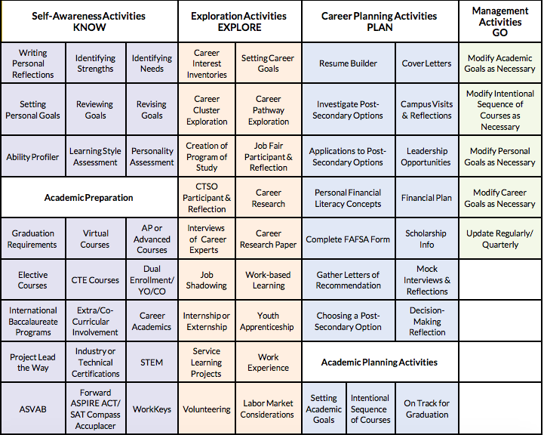

**Career Cruising**

As a part of planning services, it is required that each 6-12 student have access to an academic and career planning software tool that engages students in career exploration, planning, and preparation. Students in the School District of Baraboo will utilize Career Cruising, an internet based career exploration planning tool to learn more about themselves and develop their career plan. Career Cruising connects a student’s past and future course selections with potential future career options. Each student has a personal Career Cruising account with an e-portfolio, which is created and maintained by the student for their individualized academic, career, and personal aspirations. The student owned e-portfolio holds self-assessment results, programs of study aligned with high school graduation requirements, personal interests and individually defined career goals, as well as favorite information on schools and careers. Because it is internet based, students may access this tool from school, from home, on vacation, wherever there is access to the internet.

**Elementary ACP**

The School District of Baraboo provides a comprehensive school counseling program. Our program's design, delivery, and content are dedicated to enhancing the ability of all students to fully utilize the educational opportunities available to them. Our school counseling programs are integral to the school's educational environment, and we partner with other academic and behavioral initiatives to effect positive changes in student achievement and behavior. The PreK-12 program is delivered through direct and indirect services designed to address three domains of student development: academic, personal/social, and career.

At the elementary level, students in grades K through 5th are introduced to the world of careers. It is our goal to have students acquire the self-knowledge necessary to make informed career decisions. Specifically, we ensure the following standards are met:

*Standard G*: Students will acquire the self-knowledge necessary to make informed career decisions.

*Standard H*: Students will understand the relationship between educational achievement and career development.

*Standard I*: Students will employ career management strategies to achieve future career success and satisfaction.

Students will begin mastery of these standards as well as exploring the world of careers during K - 5 bi-monthly developmentally appropriate classroom guidance lessons. Students in grades 2 - 5 have the opportunity to participate in career interest inventories, while students in 4th and 5th grades participate in an annual career fair.

**Middle School ACP**

Students at Jack Young Middle School will engage in academic and career planning in a variety of ways. All students in 6th grade will participate in a seven-week careers class. Seventh and eighth graders will have opportunities for academic and career exploration during their core content area courses. The following table displays the activities students will be completing.

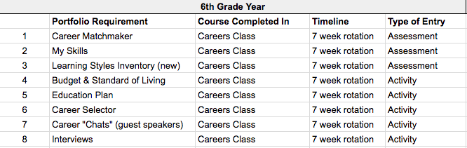

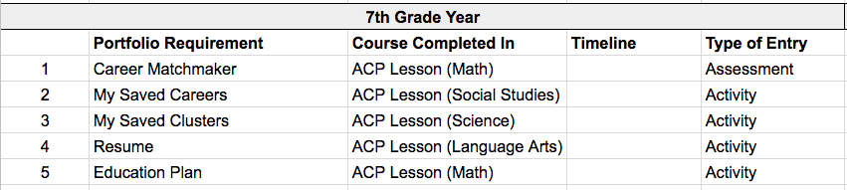

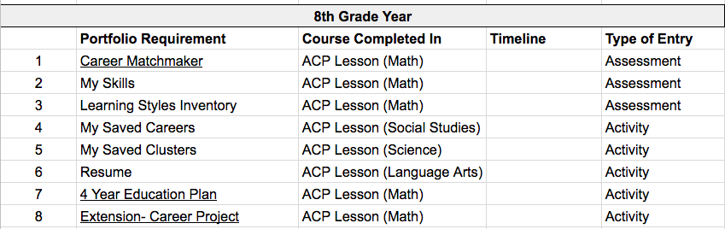

In addition to the above mentioned activities, 8th grade students meet individually with a school counselor in a student planning conference. The goal for this meeting is to engage with students to help them narrow in on a career interest or cluster. Counselors discuss high school options in order to highlight the importance of experiences and courses of study.

**High School ACP**

Students at Baraboo High School will engage in academic and career planning starting their freshman year. Requirements for Baraboo High School ACP are as follows:

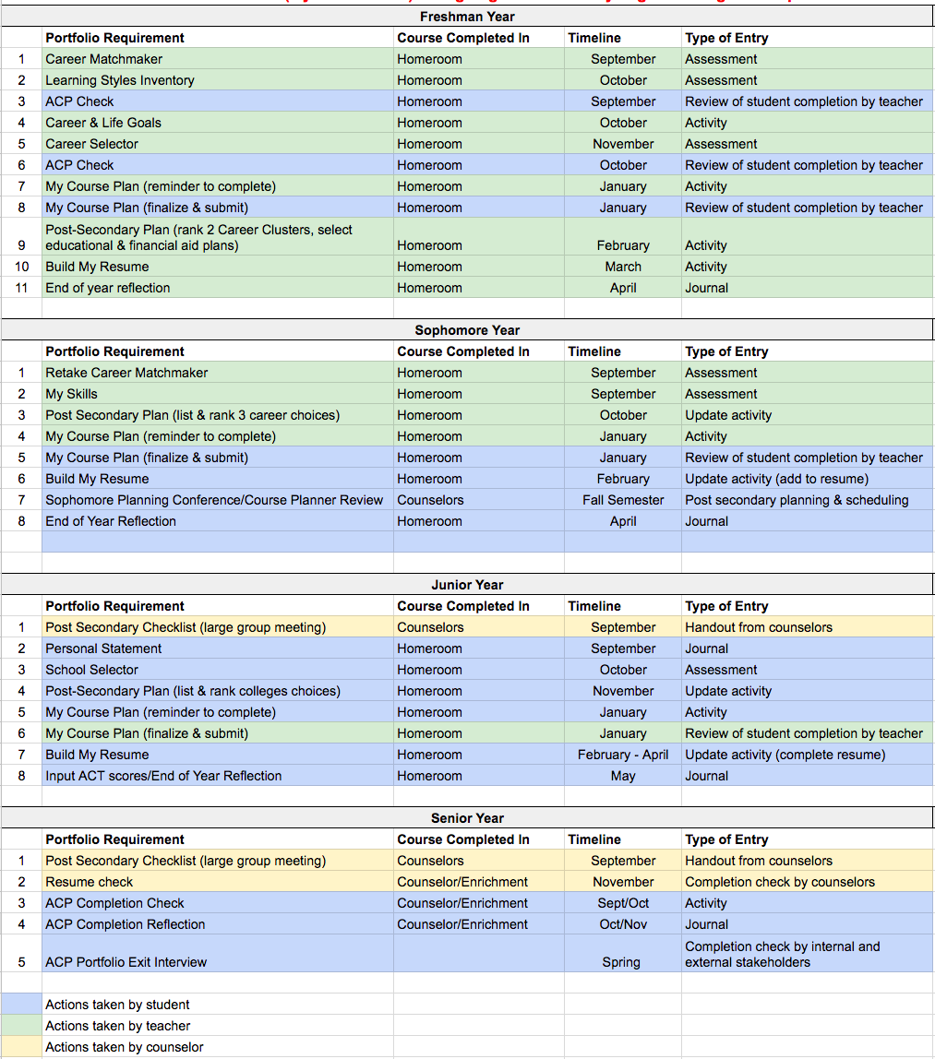

Conclusion

E4E and ACP activities hold great promise for ALL students, from those designated “gifted and talented” to those considered most at risk of not graduating from high school. The majority of students graduate with an unclear direction for their future. Through self-exploration, career exploration, and career planning and management, students become informed consumers of the education and training required to meet their personal goals.

Additional Information or Questions

For more information or if you have questions, please contact:

Dr. Nicholas Karls, Director of Teaching and Learning - 355-3950 ext. 1540

Kathy Thornburgh, Professional School Counselor (Baraboo High School) - 608-355-3943 ext. 2031

Ann Renn, Professional School Counselor (Baraboo High School) - 608-355-3943 ext. 2030

Andy Waldvogel, Professional School Counselor (Baraboo High School) - 608-355-3943 ext. 2032

Laurie Kowalke, Professional School Counselor (Jack Young Middle School) - 608-355-3930 ext. 3030

Christina Olson, Professional School Counselor (Jack Young Middle School) - 608-355-3930 ext. 3031